$fch Common Collector$:

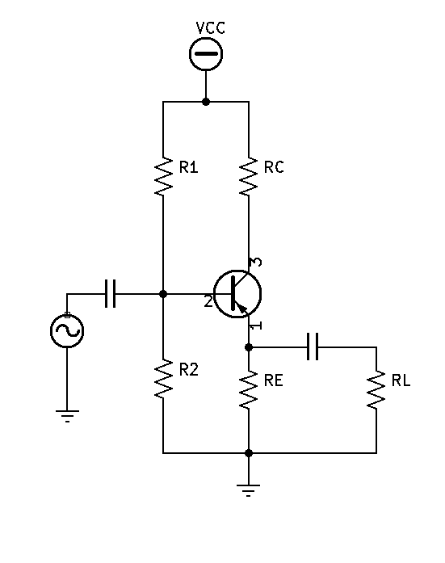

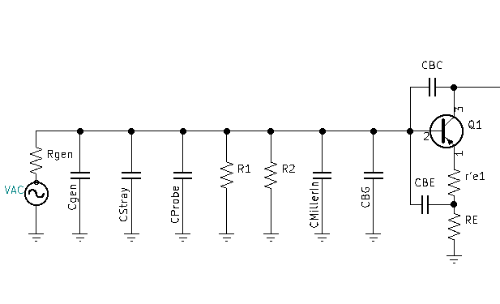

AC redraw of input at high frequency:

* Find ${Ctotal}_{in}$:

${Ctotal}_{in}=C_{gen}+C_{stray}+C_{probe}+{Cmiller}_{in}+C_{BG}$

$C_{gen}=Measure, look up Specification in Manual$

$C_{stray}≈10pf$

$C_{probe}≈16pf Measure,Specification in Manual$

${Cmiller}_{in}=C_{obo}\left(1+{∆v}_{CE}\right)$

$C_{obo}=transistor data sheet value$

${∆v}_{CE}=\frac{Vout}{Vin}=\frac{ic(RC//RL)}{ie(r^{'}e+RE)}=∝\frac{(RC//RL)}{(r^{'}e+RE)}$

$C_{BG}=C_{BE}(1-{∆v}_{CC})$

$C_{BE}=\frac{1}{2πf_{τ}r^{'}e}$

${∆v}_{CC}=\frac{RE//RL}{r^{'}e+(RE//RL)}$

AC redraw of output at high frequency:

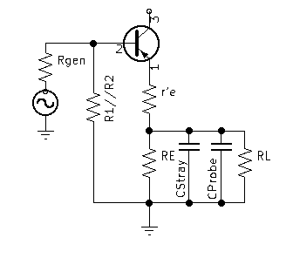

* Find ${Ctotal}_{out}$:

${Ctotal}_{out}=C_{stray}+C_{probe}$

$C_{stray}≈10pf$

$C_{probe}≈16pf Measure,Specification in Manual$

Calculate ${fch}_{total}$:

* Find ${fch}_{in}:$
${fch}_{in}=\frac{1}{2π{×Ctotal}_{in}×{Rthev}_{in}}$

${Rthev}_{in}≈Rgen$

${Rthev}_{in}=((RE+r'e)(B+1))//R1//R2//Rgen$

* Find ${fch}_{out}:$

${fch}_{out}=\frac{1}{2π{×Ctotal}_{out}×{Rthev}_{out}}$

${Rthev}_{out}=(\frac{Rgen//R1//R2}{(B+1)}+r'e)// RE//RL$

${fch}_{total}=\frac{0.35}{\sqrt{{(\frac{0.35}{{fch}_{in}})}^{2}+{(\frac{0.35}{{fch}_{out}})}^{2}}}$